POULTER (313)

Expectations:

- Be independent, make informed decisions
- Be curious, seek out new ways of learning and doing
- Be respectful, know that every person is another
human connection that can help you succeed
- Be a resource, help out others when they are in need
- Be ready to EXPLAIN! Convince me.

Organization:

Please note that organization is YOUR responsibility, not Ms. Poulter’s. As we are preparing to be productive and proactive members of society, we must understand that organization is a necessary skill for the individual to have full ownership of. Class notebooks will be required and maintained, however the maintenance of these will be your responsibility. Any loss of the school-supplied course notebook will be remedied by the student.

Algebra 1 – Geometry
& Prob and Stats
Teacher: Ms. Poulter, Room 313
Email: spoulter@noscihigh.org
Phone: (504) 330-4297
*Please do not text or call after 8pm*

Website: scihighmath.weebly.com

This school year we will build our skills in problem solving and project based learning to develop a deep understanding of mathematics and how it relates to the world around us. We will persevere in solving problems, be innovative in our ideas, and develop critical thinking skills to help us thrive in today’s world of innovation and change.
Category | %
Formative Assessments  (NTK Mastery Assessments, homework, classwork) | 35
Summative Assessments  (Project Artifacts, Tasks, Quizzes) | 50
Semester Final | 15

Grading
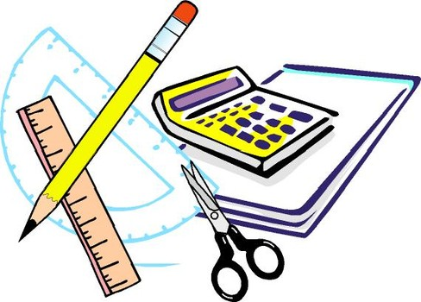
Supplies

- Personal headphones/earbuds
- Pens and pencils
- Loose leaf paper
- Two whiteboard markers
- Personal Hand Sanitizer (we use class computers and want to minimize germ transfer!)

*Math Notebooks will be supplied but Student is responsible for upkeep and replacement in the event of loss!*
Contacting Ms. Poulter:

Cell: (504) 330-4297
(Between the hours of 7:00am and 8:00pm)

Email: spoulter@noscihigh.org
Please email in a professional manner. Any misconduct via email will be addressed with the same seriousness as in-class misconduct.

Website: scihighmath.weebly.com

Additional Policies:

Professional Conduct: All Sci High policies apply (including dress code and general conduct). In addition to these policies, understand that this is a respectful and supportive classroom. In order to learn most effectively, this must be a place of work. Therefore any distractions or infringements to learning time will be handled swiftly and with appropriate action.

Absences: If you must be absent, it is your responsibility to check the Class Website! If your absence is excused, you must complete any missed assignments by the following school day. If your absence is unexcused, the original due date applies.

Mastery Retakes: Retakes for mastery grades/assessments may be allowed upon completion of remediation assignments determined by Ms. Poulter. Retakes may not be done on the same day the original assessment was completed.

Technology: As a student, it is necessary for you to take ownership of the materials that you have access to and any misconduct or mistreatment of classroom technology will be addressed according to school policy.

